PRODUCT SPECIFICATION SHEET

AIRPLUS

KHP PART No: AFR AIR ELP

DESCRIPTION

- Air freshener designed to provide fragrance in the toilet cubical.
- Fixes to top of door using double sided adhesive pads on back of unit.
- Easy load wick based consumable that is automatically activated when the cover is closed.
- Consumable lasts up to 60 days before replacement.
- Self-supporting cover with secure lock which is opened using the standard product range key.

DIMENSIONS
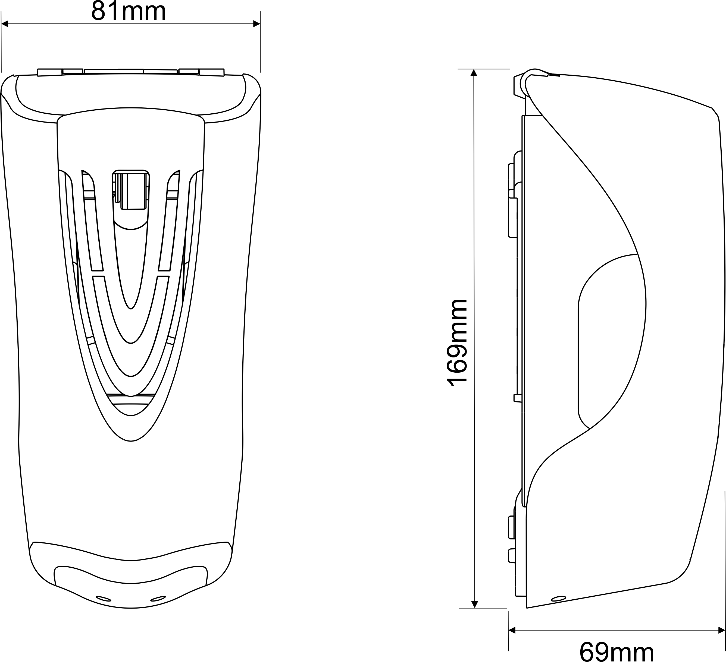

MATERIALS

Backplate moulded in glass bead filled nylon, ABS cover, and acetal mechanism. Dispenser can be recycled or disposed of in accordance with local regulations.

PACKAGING

Individual Airplus dispensers are packed in a polythene bag and packed into carton holding 18 off.
Individual weight : 147grams
Carton dimensions : 34.5cm x 22.5cm x 22cm
Total weight of carton : 3.1kg

